PRACTICAL: 1

AIM: Introduction to ERP System and Identification of ERP Domain.
ERP (enterprise resource planning)
ERP is short for enterprise resource planning.ERP (enterprise resource planning) is an industry term for the broad set of activities that helps a business manages the important parts of its business.

Enterprise resource planning (ERP) is process management software that allows an organization to use a system of integrated applications to manage the business and automate many back office functions related to technology, services and human resources.

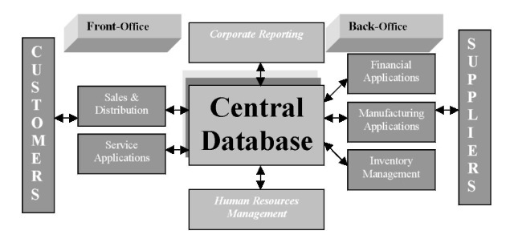
ERP system

ERP software integrates all facets of an operation, including product planning, development, manufacturing, sales and marketing.

ERP software is considered an enterprise application as it is designed to be used by larger businesses and often requires dedicated teams to customize and analyze the data and to handle upgrades and deployment. In contrast, Small business ERP applications are lightweight business management software solutions, customized for the business industry you work in.
Evolution of ERP
ERP (Enterprise Resource Planning) is the evolution of Manufacturing Requirements Planning (MRP) II. From business perspective, ERP has expanded from coordination of manufacturing processes to the integration of enterprise-wide backend processes.

Timeline | System | Description
1960s | Inventory Management & Control | Inventory Management and control is the combination of information technology and business processes of maintaining the appropriate level of stock in a warehouse. The activities of inventory management include identifying inventory requirements, setting targets, providing replenishment techniques and options, monitoring item usages, reconciling the inventory balances, and reporting inventory status.
1970s | Material Requirement Planning (MRP) | Materials Requirement Planning (MRP) utilizes software applications for scheduling production processes. MRP generates schedules for the operations and raw material purchases based on the production requirements of finished goods, the structure of the production system, the current inventories levels and the lot sizing procedure for each operation.
1980s | Manufacturing Requirements Planning (MRP II) | Manufacturing Requirements Planning or MRP utilizes software applications for coordinating manufacturing processes, from product planning, parts purchasing, inventory control to product distribution.
2000s | Enterprise Resource Planning (ERP) | Enterprise Resource Planning or ERP uses multi-module application software for improving the performance of the internal business processes. ERP systems often integrates business activities across functional departments, from product planning, parts purchasing, inventory control, product distribution, fulfilment, to order tracking. ERP software systems may include application modules for supporting marketing, finance, accounting and human resources

The Evolution of ERP from 1960s To 1990s

Benefits of ERP for your Business
- Integration across all business processes - To realize the full benefits of an ERP system it should be fully integrated into all aspects of your business from the customer facing front end, through planning and scheduling, to the production and distribution of the products you make.
- Automation enhances productivity - By automating aspects of business processes, ERP makes them more efficient, less prone to error, and faster. It also frees up people from mundane tasks such as balancing data.
- Increase overall performance - By integrating disparate business processes, ERP ensures coherence and avoids duplication, discontinuity, and people working at cross purposes, in different parts of the organisation. The cumulative positive effect when business processes integrate well is overall superior performance by the organisation.
- Quality Reports and Performance Analysis - Analysis on ERP will enable you to produce financial and boardroom quality reports, as well as to conduct analysis on the performance of your organisation.
- Integrates across the entire supply chain - A best of breed ERP system should extend beyond your organisation and integrate with both your supplier and customer systems to ensure full visibility and efficiency across your supply chain.
Business Integration using ERP
ERP integration is the process of integrating separate, stove-pipe ERP (Enterprise Resource Planning) systems with each other or with other enterprise information resources, to meet various B2B demands. Originally, ERP systems, such as SAP, PeopleSoft, Oracle and Lawson, were built with the purpose of tightly integrating processes within an enterprise.
This includes planning, manufacturing, and sales, while more recent ERP software products encompass marketing, inventory control, order tracking, customer service, finance and human resources as well.
In every ERP implementation, there comes a time where these wide-reaching, all-encompassing systems need to communicate with other 3rd party solutions and legacy applications.

Opentaps
opentaps Open Source ERP + CRM's goal is to combine the best of both open source and commercial software. We want to offer users the unlimited flexibility and innovation that comes with free access to the source code, along with the expertise and professional support of high quality commercial software.
Industry Solution
A business solution that supports both operational and administrative processes of organizations, this single solution comes with localizations—in the box—for 36 countries.
With a specialized focus on manufacturing, retail, service industries, and public sector, Opentaps includes capabilities such as financial management, manufacturing, retail, business intelligence and reporting, supply chain management, and human capital management.

Modules

Opentapsincludes the following modules:

- CRM
- SCM
- Inventory, Manufacturing, and Purchasing
- Financials and Reporting

Technology

- Enterprise Java J2EE foundations using Apache Tomcat and OFBiz projects
- Domain driven architecture embraces object-oriented development model with integrated Hibernate persistence and spring framework
- Rich AJAX user interface development with Google Web Toolkit
- Business intelligence and reporting with Pentaho and Jasper Reports
- Compatibility with MySQL, PostgreSQL, Oracle, and Microsoft SQL Server

Client/Users

- Toyota
- Honeywell
- mBox
- ToolEast
- Icebird
- Sempione

Company

Honeywell :
Honeywell International (NYSE: HON) is responsible for providing spare parts, repair, and maintenance services to both commercial airlines and governments. In one project for the United States government, Honeywell provides complete repair and maintenance services for the engine of a major vehicle system for the United States Department of Defense. This includes maintaining an adequate supply of the engine and its spare parts both in the field and at four maintenance depots around the world over the entire multi-year contracted time period.
To fulfill its obligations, Honeywell needed to plan the manufacturing of the engine and its associated parts over the contract period. This meant it had to project demand for both the engine and the parts over several years and take into account field demand for the engine, the bill of materials which specified its parts, and the existing stock of the engine and parts in the various maintenance depots. The particular engine has over 1600 parts in a nine-level bill of material. The analysis also had to account for the ability of the depots to refurbish some of the spare parts so that they could be used again for future maintenance. Finally, Honeywell needed to examine multiple demand scenarios to determine the adequate level of stock.
Traditionally, this complex analysis was done by 25 Excel spreadsheets with custom models that used pivot tables and lookups. Their original goals were to create a centralized database for all the demand forecast data, and then develop a custom model to analyse the data and project inventory levels and production requirements.
LMCI, however, suggested a novel approach: They recommended that Honeywell use the opentaps Open Source ERP + CRM system and leverage its existing supply chain management features for inventory planning, instead of rebuilding its custom models from scratch.
"When we first mentioned 'ERP' to the Honeywell team, they were reluctant," notes Jim Carrillo, President of LMCI. "To them, 'ERP' was a four letter word that meant big, expensive, and time-consuming. However, we pointed out that using opentaps had some important advantages. First, because opentaps is an open source ERP system, it was free. More importantly, it was much easier to implement compared to the large commercial ERP systems that the Honeywell team was used to. Finally, opentaps came with out-of-the-box features for inventory planning which already followed best practices, so that gave us a lead coming out of the starting gate versus developing a custom solution from scratch."
Working with Open Source Strategies, Inc. the lead developer of opentaps, LMCI then proceeded to implement a specialized solution which integrated inventory data and projected demand from Honeywell into the opentaps system. This data was created in opentaps as sales orders and warehouse inventory. opentaps then ran through its Material Resources Planning (MRP) system which was part of its purchasing and supply chain management application, projected for demand for both the engine and all 1600 parts, level by level down the bill of materials. It then created requests to transfer inventory and parts between the maintenance depots as needed and finally created a multi-year master production schedule.
"What was really interesting here is that we were able to tap into the power of an ERP system without having to implement a full ERP system," says Si Chen, Principal of Open Source Strategies, Inc. "People are too used to thinking of ERP as a big black box to run an entire enterprise. opentaps can do that, but it can also be a toolbox of best practices for solving problems like inventory planning."
The entire project took less than three months for the combined Logistics ModelingCenter and Open Source Strategies team to complete, including customizations, reports, and documentation. "Open source definitely made a difference: leveraging the existing features from opentaps allowed us to complete the project much faster than originally planned," notes Jim Carrillo of LMCI.
PRACTICAL: 2

Aim: Resource Identification And Categorize Resource.

Software Requirements
- System need to have at least 512 Mb of heap space assigned to the virtual machine is actually running it.
- System must have the java based platform installed and the ant utilities for installing the application.

Hardware Requirements
- The Base system must have the hard-drive space of atleast 10GB and the RAM of 384MB.
- The Main Guidelines for the Hardware Server Configurations are :
  - For demo and training, you need a single CPU server with 2 GB of memory with about 1 GB allocated to opentaps. This is equivalent to the Amazon EC2 Small Instance.
  - For a small deployment (under 10 users), a dual CPU server with 4 GB of memory should be sufficient.
  - For moderate deployment, we would recommend 4 CPU cores with about 8 GB of memory. This is equivalent to the Amazon EC2 Large Instance.
  - It is not possible to deploy the application on shared hosting environments, such as those offered for $10 per month. While you technically do not need root access to run the application, shared hosting usually involves minimal memory allocated to each account and extensive disk swapping.

Recommended
- a PDF viewer if you use convert reports into PDF.
Human Resources
- For Development of project
  - Developers team of 25 people with 5 allocated for weekly unit tests and 3 for Business Logic and Database backend , 2 for database server compitibility with the business logic, 10 for the resource planning of the organization and deriving the structure of management panel for operation from various department, 5 for the integration testing and 3+2 for requirement gathering and process design. ( for a medium sized organization )
- For operational features
  - Operational ERP team of about 7 people to handle and manage the data monotoring in the ERP. There will be a seperate user panel for the members of the organization for the port to use the ERP for the data entry and quering with reports to publish and other purposes.
PRACTICAL: 3
Aim: Enterprise Process Identification.
opentaps offers a complete solution for your business, from your online store and sales teams to customer service, warehouse, inventory, shipping, manufacturing to accounting and reporting. It also can link your retail stores with an integrated point of sales system. Here are some of the most popular features in opentaps:
eCommerce Online Store
- Support unlimited stores, catalogs, categories, and products
- Cross-sells and upsells for products
- Support physical products, digital and downloadable products, variant products, configurable products, and customer gift cards
- Price rules for customer or group-specific pricing
- Online store promotion engine
- Integration with major payment gateway providers
- Fully integrated online and Point of Sales (POS) stores out-of-the-box
- Keyword search capability in all the applications using hibernate search

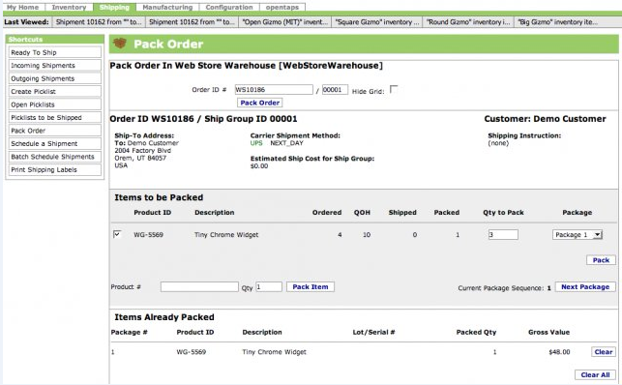
Online store
CRM Features
- Automate sales process from lead gathering to conversion
- Manage sales opportunities
- Create sales visibility with forecasts
- Share calendar and tasks with the entire team
- Share and manage documents
- Browser-based email with integration to email server
- Customer services and case management
- Quotes, order entry, and order prioritization
- Manage marketing campaigns, including outbound emails and call management
- Tracking code reporting and management
- Address lookup and correction via USPS
- Integration with Asterisk open source Voice over IP (VOIP) system
- Integration with GetResponse email marketing with opentaps-GetResponse integration module
- Support for Value Added Taxes (VAT) through VAT module

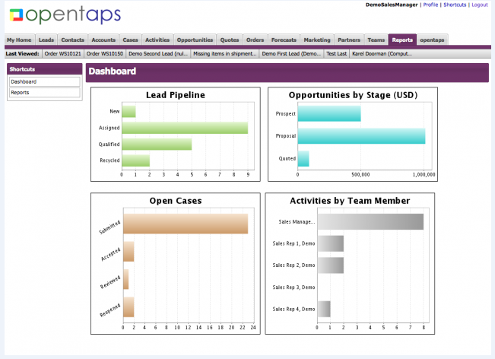
CRM module
Warehouse and Manufacturing Features
- Integration with UPS, FedEx, DHL, and Endicia Track non-serialized, serialized, and lot-based inventory
- Host third-party or "virtual" inventory
- Manage entire manufacturing process with Bill of Materials (BOM), production tasks, and work orders
- Fulfill orders efficiently with picking lists, web-based packing station, and shipment scheduling
Financial Management and Accounting Features
- Industry standard double entry general ledger
- Supports multiple organizations with unlimited hierarchy of accounts
- Manage accounts receivables (AR) and accounts payables (AP), including invoices, payments, statements, aging
- Produce financial and tax statements, including income statement, balance sheet, cash flow statement, trial balances, tax summary and detail reports
- Fully integrated with orders, inventory, purchasing, manufacturing out-of-the-box
- Scheduled transactions postings
- Recurring invoices
- Third party billing support
- Ability to segment financial results using "tags" for divisions, departments, product lines, activities, etc.
- Budgeting and encumbrance reporting
- Ordering and invoicing of services
- Support for Value Added Taxes (VAT) through VAT module
- Additional reconciliation reports and AR/AP funcationality through Enhanced Financials Module

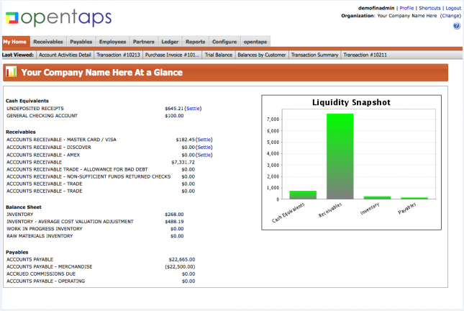
Finance module

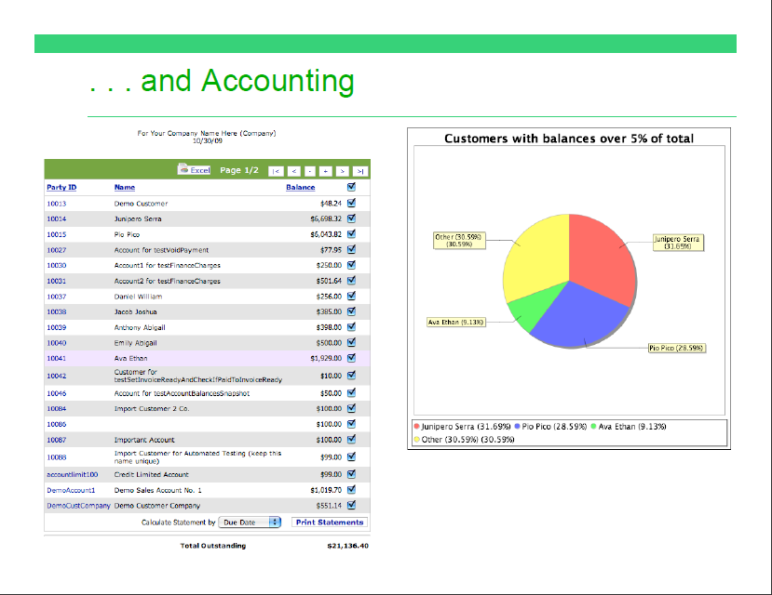
Purchasing and Supply Chain Management
- Manage Suppliers records, including contact information
- See real time inventory
- Automate production and purchasing calendar with Material Resources Planning (MRP)
- Use requirements to streamline purchasing work flow
- Support for Value Added Taxes (VAT) through VAT module
Business Intelligence and Reporting
- Support for data transformation using Pentaho open source business intelligence
- Graphical WYSIWYG report writer (iReport) and ad hoc reporting using Jasper Reports
- opentaps Analytics allows in-depth look at customer and sales data
Technical Highlights
- Built on Java J2EE with a Service Oriented Architecture and Model-View-Controller framework
- Compatible with all major databases, including MySQL, PostgreSQL, Oracle, and SQL Server
- Support for XML RPC, SOAP, and SyncML integration protocols
- Incorporates the Apache Tomcat and Geronimo servers
- Supports Java 6
- Combines Apache OFBiz framework with object-oriented domain driven architecture
- Ajax widgets with the Google Web Toolkit
- LDAP and Kerberos Single Sign On (SSO) support
- SSL support, OWASP, and encryption of sensitive data for security
Additional modules
- Project management
- Human resources
- Fixed asset management
- Outlook and mobile phone integration with Funambol
- Integration with eBay, Google base, Google check out
- Content management
- Point Of Sales
- Magento ecommerce integration
PRACTICAL: 4
Aim: Introduction to Business Process Reengineering (BPR).
What is BRP?
- Business process re-engineering is a business management strategy, originally pioneered in the early 1990s, focusing on the analysis and design of workflows and business processes within an organization.
- BPR aimed to help organizations fundamentally rethink how they do their work in order to dramatically improve customer service, cut operational costs, and become world-class competitors
- BPR seeks to help companies radically restructure their organizations by focusing on the ground-up design of their business processes.
- Re-engineering recognizes that an organization's business processes are usually fragmented into sub processes and tasks that are carried out by several specialized functional areas within the organization.
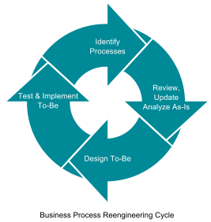
- Business process reengineering (BPR) is the analysis and redesign of workflow within and between enterprises.
- BPR's main objective is to break away from old ways of working, and effect radical (not incremental) redesign of processes to achieve dramatic improvements in critical areas through the in-depth use of Information Technology.

Connection between ERP and BRP:
- Enterprise resource planning (ERP) is a software platform that helps business owners determine how to best use their available resources.
- Business process re-engineering (BPR) involves observing and analyzing how the business works to determine changes that may streamline operation at the business.
- ERP and BPR can go hand-in-hand. An organization's management might use BPR as a means of looking at the current operations of a business to determine how to best proceed when designing or choosing a new ERP.
- Just like ERP and BPR can be used together to improve an existing ERP platform, a business executive can benefit from using an existing ERP to enhance the effectiveness of BPR.
- One of the advantages to an ERP is that it stores integrated data from all parts of the program, allowing an executive to access and examine data to plan the most effective business process changes.
- ERP and BPR can also be used together to facilitate change management.
- Once BPR is completed and the course of change has been determined, ERP can be used to facilitate communication and information exchange for staff members affected by the readjustment process.
- BPR can also be used to help establish the most effective way of implementing ERP use for an existing workforce.
- ERP programs help business owners manage their finances, keep employee records and schedule the use of their assets, whether the assets include buildings, machinery, work, or money.
- ERP and BPR are most often used together to improve operations in a business with a fundamental problem in organizing its processes and resources.
Implementation of BPR in LOT Vacuum Company:
- Founded in 2002, LOT Vacuum is a company that specializes in vacuum for semi-conductors and displays.
- After 10 years of steady growth in technology and reputation, LOT Vacuum embarked on the significant journey of revising its entire organization. LOT Vacuum underwent major innovation for IT as the company undertook BPR.
- LOT Vacuum’s innovation activities were undertaken in over 30 categories including management, manufacturing, and customer support.
- At the core of these activities lay the need for establishing advanced business processes through Business Process Reengineering (BPR) and re-implementing major systems such as ERP
- Based on the new processes drawn up by the BPR consulting work, AXI4CNS began to develop a new architecture for the backbone systems by pairing the ERP system and the PLMS together.

Benefits:
- Paperless Management Meetings with EIS(Executive Information System)
      - Full Lifecycle Management from Development to Customer Support
      - Increased Customer Satisfaction

Advantages and Disadvantages of BPR:
Advantages:
BPR brings numerous benefits to organizations and companies in which it is implemented. Some of the common benefits of BPR are:
- Increase Effectiveness:
All processes are completely monitored under the strict control of the management. The net result of this is that employees deliver high quality products to their customers. Helps to improve efficiency.
- Reduces cost:
With the proper management of processes, improved efficiency and quick delivery of products to the buyers, the overall product costs are reduced resulting in cost saving for the organization in the long run.
- Meaningful job for employees:
As the time lag of product processing between different departments gets reduced due to the application of business process reengineering, there are more meaningful tasks to be performed by employees. This leads to increase their levels of motivation and the desire to perform well.
- Improvement in organizational approach:
When most organizations have implemented business process reengineering there is an increase in flexibility and adaptability for change. This has created better environment for people to work, thus leading to employee satisfaction.
- Growth of business:
Implementation of BPR results in the growth of the present business thus enabling the emergence of new businesses within the same organization.

Disadvantages
- Requires Investment:
BPR typically requires an investment, particularly in technology. Outdated methods, such as doing a task by hand, face replacement by computer programs.

- May Lower Worker Morale:
Management must provide support and guidance during BPR. Failure of the management team to assist workers and set an example during the BPR process may lead to failure, disorganization and staff problems.
- Higher Demands to the Workers:
Due to the environment of flexibility and change, it is clearly impossible to hire people who already know everything they're ever going to need to know, so continuing education over lifetime of a job becomes the norm in a reengineered company. This tends to increase in demands for workers.

PRACTICAL: 5

Aim: Establishing New System as BPR and Impact Analysis of new

System as BPR.
Business process reengineering (BPR):How to implement in a new system
- Business process reengineering (BPR) is the analysis and redesign of workflows within and between enterprises in order to optimize end-to-end processes and automate non-value-added tasks.
- BPR implementation can be either successful or unsuccessful. A successful BPR implementation is considered to be one that yields the expected improvements in productivity and quality. An unsuccessful implementation is one that does not.

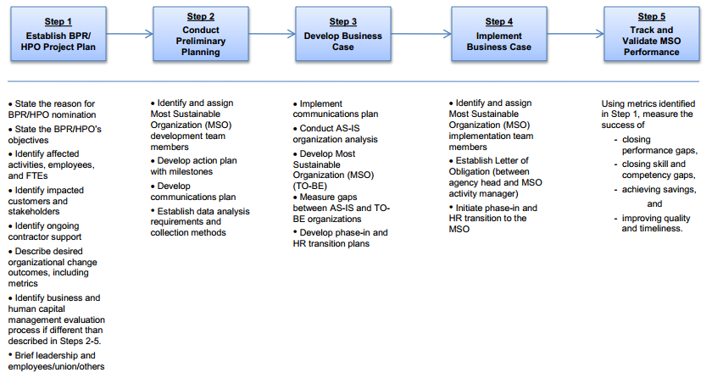

Steps(to implement BPR in a new system ):
- Project kick off: Project goal, project team and communication standards are agreed upon. A number of workshops are held where project scope, sponsors commitment, project risk, milestones and deliverables are discussed. A SWOT (strength, weakness, opportunities and threat) analysis is carried out with active participation of all.
- Process identification and data gathering: “As is” processes are assembled through flow charts. Current practice of Interfacing with business partners is gathered. Bottlenecks, delays, complexity, internal blame games, idle assets etc. are brought forward. Use of existing technologies is comprehended. Major and strategic business processes to be reengineered, are identified. Stakeholders categorize the processes to be reengineered and agreed upon on the timeline of implementation.
- Process Reengineering: In this phase, actual reengineering begins. A number of brain storming sessions are held with project team and other stakeholders, where current business processes are critically analyzed to determine non value adding activities and identify excess control and check, always with customer value as a focal point. Impact of new technologies on process improvement is also evaluated. New process ideas with reduced check and control and enabling technologies such as Workflow automation and ERP, are envisaged. Benchmarking is also done with best of breed industrial peers.
- Blueprint of new system: Blueprinting involves modeling workflow and information requirement, of new business processes. “To be” processes are modeled using various modeling tools. New organization structures, human resource need, performance monitoring and compensation, technological needs, are also outlined. Normally, a first cut redesign scheme is produced which is modified after gathering actionable feedback from the stakeholders.
- Transformation: A migration strategy and a migration plan is the first step of transformation. Migration strategy may decided as a pilot, phased or big bang implementation. The migration plan would include establishment of new organizational structure, detailed training and reallocation of workforce, and cut off dates for implementation. Change management and introduction of new technologies will form an important part and may need engagement of outside consultants for this specific purpose.
Impact analysis of New System as BPR:
- Past research has BPR proponents that suggest that BPR has serious effects on the organizational strategy and that it is a process that needs a proper approach to be followed if it is to bring expected success.

- The functionality and existence of any organization revolves around its strategy which is derived from its mission and vision. It is therefore important that the organizational strategy should be seriously considered during BPR in order for the resultant business processes to be a true representation of the organization.

- The mission statement where strategy is derivedfrom defines the purpose of the organization and describes what sets it apart from others in its sector. Vision statements serve as milestones which define where theorganization is going, thereby providing a clear picture of the desired future position for the organization.

- According to Hemal & Prahalad, 1994 in a business minor changes or improvements might not bring the success or affect the business directly to bring the results and BPR is a strategic option for the top managers of the businesses.

- Most importantly, the mission and the vision must be built into a clear organizational strategy that distinctly defines its competitive position if objectives are to be attained. The performance of each process is then measured at optimal level after BPR to ensure correct output with regards to what the process is supposed to do as well as alignment to organizational strategy.

- Hammer(2008) emphasizes that for BPR to succeed; it should be aligned to the organizational strategy. The issue of BPR/ organizational strategy alignment plays a very important role in organizations in the sense that BPR is change to business processes and business processes are a way to implement organizational strategy.

- BPR normally increase the competitiveness of the firm in the long run and short run. In the case of BPR, analysis shows this process consists of concealed and indescribable proportions which lead failure of this process.

The Role of the Leader and the Manager:
- Many articles point out that BPR must have the full support of top management to succeed. If resistance is encountered, the leader must be willing to "drive" change, even to the point of ruthlessness.
- One article even exhorts the leader to emulate a private detective -- such as Philip Marlowe -- who adheres to the following "heroic" qualities; Relentless adherence to what is right; Courage -- moral as well as physical; Recognition that surface appearance is often an illusion;
- According to one executive with BPR experience, "Once the [reengineering] plan is in place, you've got to pull out the stops and execute it.
- You cannot live in limbo between what you used to do and what you're going to do." Otherwise, the dramatic results are sacrificed, people lose their focus, and "reengineering slips into process improvement." Employees may be enthusiastic about reengineering during the initial phases if they view it as a "win- win" situation.
- Some companies experience resistance in later stages when employees begin to harbor doubts about the impact of reengineering, and managers are forced to adopt a more "insistent" policy.
- CSC Index points to poverty of ambition as a reason why BPR projects fail. "Companies that just flirt with [reengineering] suffer the pains without the gains." Reengineering advocates urge management to pull out all the stops and implement change on a grand scale.
- Managers in the organizations after reengineering are compared to coaches. They do not order; they guide. They do not direct the work of others; they coordinate, facilitate and empower.

Examples of positive Impact in BPR:

- Many public and private sector organizations and SMEs Word-wide had undergone major reengineering efforts. Thetechnique was applied first to multinational co-operations, suchas IBM, AT&T, SONY, GENERAL ELECTRIC, WALL MART, HEWLLETPACKARD, DEC, KRAFT FOODS having as a result major downsizing in theirorganizational structures.

- Later, the banking sector began to reengineer with a great degree of success such as CITIBANK , NORTHWESTERN BANK, BANK OF AMERICA and others.

- A BPR effort on its IT infrastructure taught National Commercial Bank Jamaica Ltd. (NCBJ) an important lesson:

- To realize the big paybacks from such a project, you need to do a thorough, upfront analysis of business processes and workloads. Then you can optimize processes and allocate resources where they'll do the most good.

- First the government cabinet of Egypt reengineered its processes along with many Municipals in Europe. The public health sector is undergoing a major re-engineering in Europe using the CORBA methodology.

Examples of negative Impact in BPR:

- The OR team had its work considerably hindered by the opposition posed by PubliCorp's staff. The OR group analyzed and modeled several processes with difficulty, which added uncertainty to the subsequent redesign proposals and related structural change. Additionally, two pilot process redesign attempts involving two distinct departments failed in the implementation phase, mainly due to lack of interest from staff.

- Another problem faced by the OR group was that some redesign proposals foundered on regulations established by law. The process of setting up public bids, for example, was identified as extremely complex and cluttered with several unnecessary activities. Moreover, this was one of the most frequently executed processes at PubliCorp.

- That process was analyzed and redesigned by the OR group several times. All redesign proposals were discussed with lawyers, regarding their legal validity. These discussions, though, found that most of the changes proposed might invalidate the result of future bids. Only slight changes in the process could really be implemented, without making the process prone to be contested by lawyers representing companies that had lost bids to others.

THREE REASONS FOR THE FAILURE:

Political and objective goals were leveled:
- One of the main problems every re-engineering group will face in a public organisation is the
- multitude of purposes that these organisations may have to serve. PubliCorp's CEO, supported bysome of its top management, was initially looking for radical quality and productivity improvement.

- However, the progress in the re-engineering attempt clearly indicates that he was prepared to acceptother results - provided that they were at least "apparently" positive.

The OR group gradually shifted its focus:

- The shift in the focus of the OR group, from re-engineering to process automation, is clear from thenarrative. However, during the re-engineering attempt that shift was not easy to perceive andtherefore to counter. This is particularly valid in cases where the radical process-focused
- characteristic of re-engineering is not well understood, or tends to be avoided due to barriers thatmay show up on the way. Two significant barriers to the OR group work at PubliCorp were thegeneral opposition faced from PubliCorp's staff, and the limitations on change imposed by law.

A double bind prevented recovery:

- In the case, the lack of understanding of the true nature of re-engineering did not seem to be themain reason why the focus of the re-engineering attempt moved from radical to incrementalimprovement.

- The double bind comprises two norms, the one that says "hide errors" and its oppositethat says "reveal errors". If managers choose the first norm they know that what they do is necessaryyet counterproductive to the organization.

PRACTICAL: 6
Aim: CASE STUDY.
Introduction:
Interactive Trade Center B.V. (ITC-BV) is an online retail company based in Utrecht, the Netherlands. Established in 2006, the company offers several lines of consumer products through the Internet, both directly to consumers and to other businesses. ITC-BV is a virtual company whose success depends on close cooperation with several strategic partners. One of these strategic partners provides the logistical support, including inventory management and order fulfillment. Such an arrangement allowed ITC-BV to focus on its core competence of creating online businesses. As ITC-BV grew, however, collaboration with its fulfillment partner became increasingly difficult due to the lack of a robust, automated system. The large number of errors in order processing and low efficiency in fulfillment prevented ITC-BV from growing into new product lines and market niches.
As a result, the management of ITC-BV decide to seek a better solution to enhance cooperation with its strategic partners. Even though Interactive Trade Center B.V. was a relatively small company with limited resources at the time, its management viewed the choice of a technology platform as a crucial long term business decision. It considered both commercial solutions, such as SAP Business One, and open source alternatives, includingopentaps Open Source ERP + CRM. After examining the features and usability of the systems, ITC-BV selected opentaps for its lower cost of ownership, flexibility, and ease of use. It began by using the warehouse and CRM modules of opentaps immediately and gradually brought online more functionality and integrated opentaps with its existing sales channels. Overall, ITC-BV took more than a year to get all its activities into opentaps Open Source ERP + CRM through a process of continuous training and improvements.
With the opentaps open source Enterprise Resource Planning (ERP) system, Interactive Trade Center BV has gained a significant advantage over its competitors. By connecting all activities within the organization, opentaps has helped ITC-BV realize important savings by automating business processes. It has also helped ITC-BV outsource more of its activities to partners and create greater value for its customers. Therefore, in a little over a year after beginning its implementation of opentaps, ITC-BV has already reached the "sweet spot" of achieving greater efficiency with minimal additional effort.

Some specific ways that opentaps has helped ITC-BV include:
- The warehouse management functionality within opentaps has given ITC-BV its biggest advantages. With opentaps, sales orders are automatically imported into the system, and the fully automated warehouse management generates order picking lists automatically. Barcode scanners are used with opentaps to identify products quickly. Products received by assigned employees are scanned into opentaps, and the stock is automatically updated in real time. This has greatly reduced the chance for errors within the warehouse. At the same time, employees can process the incoming orders much more quickly. Finally, up-to-date inventory levels are reflected on ITC-BV's online retail stores.

- With opentaps CRM, ITC-BV can now connect its customer service and order fulfillment partners directly with its customers. By linking emails with customer accounts, opentaps allows customer service representative to see the history of customer requests and which ones have already been processed versus pending. The planned integration with Asterisk VOIP will further enhance the ability of the customer service department to manage its customer contacts via the Internet telephony, instead of relying on traditional the telephone exchange.

- Finally, the integrated accounting and financial mangement in opentaps has allowed ITC-BV to access financial results such as trial balances, cash flow statements, and other reports on demand with live data. This has helped ITC-BV better understand its financial results.
With opentaps, ITC-BV has become a more efficient online retailer. opentaps has freed ITC-BV from the traditional constraints imposed by physical locations and resources and allowed it to connect with its business partners and customers online. opentaps has also helped ITC-BV structure and organize its internal business data more effectively with its rigorous data models, and this serves as a foundation for ITC-BV to integrate with more partners and online sales channels.
PRACTICAL: 7
Aim: ERP Implementation-package selection.
Introduction:
- ERP implementation lifecycle focus on the ERP project which is carried out to make ERP up and running.
- ERP project is likely to go through different phases like any other project.
- Most often these phases do not necessarily depend on one another in a sequence, i.e. one phase might start before previous phase has finished.
- Also all phases that will be discussed may not be applicable in all cases.
- The different phases of ERP implementation are:-
- Pre-evaluation Screening
- Package Evaluation
- Project Planning Phase
- Gap-Analysis
- Reengineering
- Configuration
- Implementation Team Training
- Testing
- Going Live
- End-user training
- Post – implementation

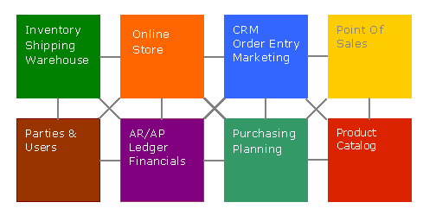

Opentaps service oriented architecture:
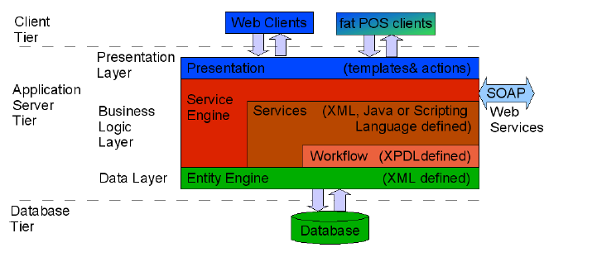

opentaps Open Source ERP + CRM's goal is to combine the best of both open source and commercial software. We want to offer users the unlimited flexibility and innovation that comes with free access to the source code, along with the expertise and professional support of high quality commercial software.
Free Software
We believe that only with free access to the source code can users create solutions which truly fit their needs. We also believe that open source is an extremely efficient software development process, as the free access to source code can unleash the collective innovation of a global community.
Therefore, we've made opentaps Open Source ERP + CRM freely available. It's "free" as in "free speech," so that you can modify it as much as you need, without any obligations. It's also "free" as in "free lunch," so you can freely download and use a production-ready, enterprise-grade ERP system. If you are technically knowledgeable or have unique needs not covered by our expertise, this is probably your best option.
Expertise and Professional Support
As the developers of opentaps, we also know a lot about it. We know what features are available and how they should be used. We've learned from experience how it should best be deployed, customized, and implemented. We also have an idea of what future releases may contain and how best to stay compatible with them. Finally, we support other users with patches, upgrades, and documentation.
If your needs coincide with our expertise, we and our partners can offer you significant value with services such as automated updates, certified implementation, and professional support. We can help you get more out of your software by taking full advantage of its features and technical strengths. We can also help protect your investment over time through future releases and upgrades. We can mentor you or your developers and help you tap into the power of opentaps ERP + CRM faster. Thanks to economies of scale, we can do all of this more efficiently than most users could on their own.
The revenues from professional services and support, in turn, help fund continued open source development, completing the cycle that will one day make opentaps Open Source ERP + CRM one of the best enterprise software solutions--open source or commercial.

PRACTICAL: 8
Aim: ERP-Module description.

Opentaps Delivers as Supply Chain Solution for Honeywell International.

Honeywell International (NYSE: HON) is responsible for providing spare parts, repair, and maintenance services to both commercial airlines and governments. In one project for the United States government, Honeywell provides complete repair and maintenance services for the engine of a major vehicle system for the United States Department of Defense. This includes maintaining an adequate supply of the engine and its spare parts both in the field and at four maintenance depots around the world over the entire multi-year contracted time period.

Honeywell use the opentaps Open Source ERP + CRM system and leverage its existing supply chain management features for inventory planning, instead of rebuilding its custom models from scratch.

Purchasing and Supply Chain Management
- Manage Suppliers records, including contact information
- See real time inventory
- Automate production and purchasing calendar with Material Resources Planning (MRP)
- Use requirements to streamline purchasing work flow
- Support for Value Added Taxes (VAT) through VAT module

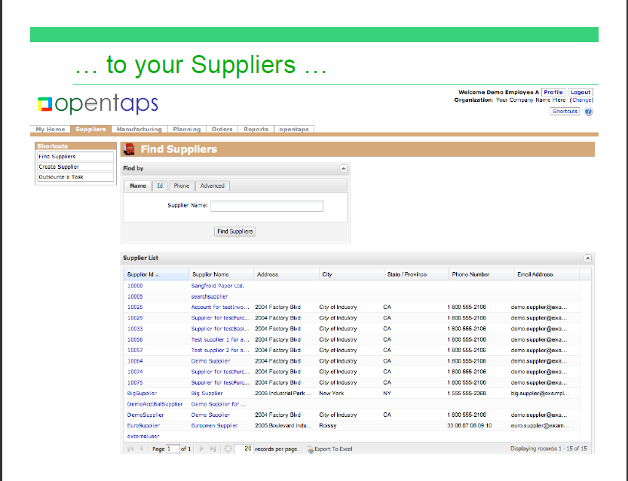

Supply Chain Management module

PRACTICAL: 9
Aim: Case study ERP and E-Business.
Introduction
- E-business has changed the definition of enterprise systems.ERP focuses on core business functions, while E-business pushes the ERP from inside core of the organizations to the network edge.
- By making use of E-business approaches, organizations can have the ERP integration benefits of flexibility, reduction in cost, more effective and quick responses etc.
- By integrating ERP with E-business, a new extended ERP system emerges that creates business which is more lively, more focused and highly competitive than traditionally structured business.
- By using Internet and WWW services, organizations are implementing PDM(Product Data Management),SCM (Supply-Chain Management) and CRM(Customer-Relation-Management capabilities.
- These systems enable companies to link their operations seamlessly with customers and suppliers.

E-Business:
- The definition of E-Business is ‘an enterprise designed for success in the Information Economy.
- E-Business brings into play an organization’s resources and partners in new and innovative ways to create clear strategic advantage.
- The potential of E-Business goes far beyond new technologies – to impact and engage all aspects of a business – strategy, process, organization, and systems – to extend the business beyond its own boundaries – where there are no boundaries...’

E-Business and ERP: Bringing two Paradigms together:
Benefits derived from ERP Implementations:
- Bringing people and processes which traditionally were physically and/or logically separated together in a collaborative environment.
- Replacing inventory with information by being able to produce more accurate forecasts.
- Relieving users from routine tasks and freeing them up to focus on value adding activities.
- Standardizing of business processes across the enterprise on a global basis.
- Centralized control of system configuration and master data ensuring data integrity.

Benefits derived from E-Business Implementations:
The reasons why companies in all sectors of the economy are embarking on E-Business projects is the need to derive benefits attributed to E-Business which are necessary to stay ahead or at least keep abreast with competitors in an increasing fast-paced environment.

Those benefits are
- Gathering information about customers that will enable the business to anticipate and satisfycustomer’s needs.
- Increasing customer loyalty by focusing on customer relationship management across the entire life cycle, using techniques such as real-time dynamically customizable web-pages created from self-generated preference profiles.
- Establishing a global reach to customers and suppliers, cutting purchasing costs and broadening market share.
- Reducing dramatically the costs of transactions with business partners (customers and suppliers).
- Reducing dramatically the time it takes to complete a transaction with a business partner.
- Easy sharing of information with business partners, thus reducing the need for high inventory levels.
- Enabling collaboration between business partners to work jointly on solutions/products for the marketplace, reducing cycle-time.
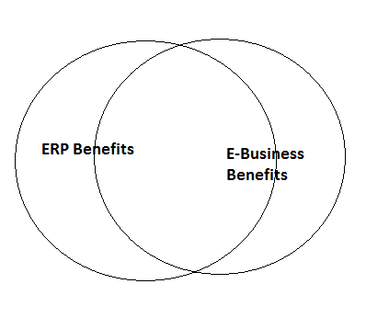
Fig: Benefits overlap between ERP system and E-Business Application.

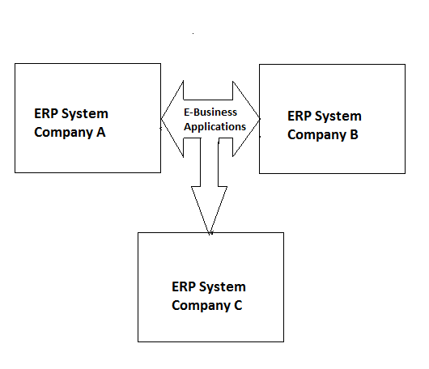
Fig: E-Business Applications supported by ERP systems

Aligning business processes, people, technology and organization between
ERP and E-Business:

- To make an E-Business implementation successful, it must be aligned with the ERP foundation on which is being build.
- It is more than likely that adjustments to the strategy, processes and technology, whichsupport the ERP system and vice versa will be necessary so they can meet the needs of E-Business.
Business Process:
- E-Business will enhance existing value chain to cross company boundaries in many ways.
- For example, in the procurement area, B2B procurement will streamline internal processes such as requisition approval and purchase order creation as well as external processes.
- Suppliers will be able to monitor inventory levels and improve their own ability to forecast, thus truly integrating themselves in the value chain.
- It is likely that some suppliers will emerge better equipped and willing to participate in this collaborative environment than others.

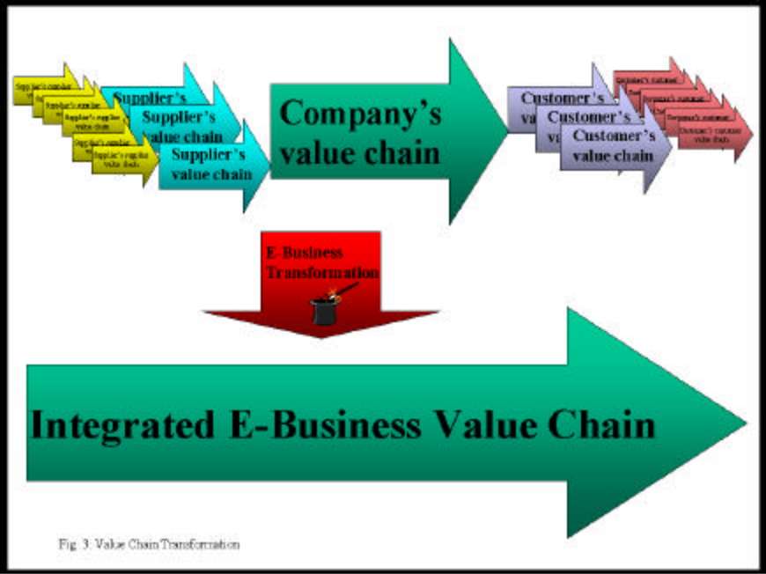

People:
- The emergence of E-Business as a new differentiating factor between companies changes the skill requirements for the both the people implementing E-Business solutions and those who are using the enhanced value chain.
- In terms of alignment of the skillsets required for ERP and E-Business implementation, it seems apparent that E-Business takes the enhancement of skills, which began with ERP implementations a step further.
- While in an ERP environment, the combination of technical skills and business knowledge is a strong advantage, it becomes a necessity in an E-Business environment.

Technology:
- Development and deployment never stops in the transition process to an E-Business environment.
- Thepace of change affecting technology, competitive landscape and business model means that companieshave to plan for more rapid life cycles for their E-Business applications than their ERP systems.
- Thiscreates a problem for aligning the two platforms, which from a business prospective need to work seamlessly together.
- A trade-off between protection onthe one hand and functionality, ease of use and performance will be the result and ownership andaccountability needs to be established.

COMMON ERP/E-BUSINESS PLATFORM (ORACLE & SAP)
SAP
- SAP ERP is a world-class, fully integrated application that fulfills the core business needs ofmidsize companies and large organizations across all industries and market sectors.
- It helpsenterprises to manage financials, human capital management, procurement, logistics, assetmanagement, and corporate services.

ORACLE
- Today's ERP software needs to be scalable, affordable and easy to use. Oracle, the number oneplayer in ERP, and the dominant supplier of relational database to the Windows NT and Unix market, became a leading independent software company worldwide.

- Oracle’s Internet Platformprovides a comprehensive solution for ERP integration. Based on the popular hub-spoke-adapter architecture, Oracle uses XML to extract information from legacy and ERP applications.

- Theinformation will be renderable through “Portlets” on the desired site. NDS Systems has met this challenge by creating Oracle-based ERP applications for small to mid-sized organizations in the manufacturing, distribution and fulfillment industries.

Commonalities and Differences between ERP and E-Business Implementations
- While many of the benefits derived from ERP and E-Business implementations are similar or evenidentical, the nature of those implementations is quite different
- To achieve the maximum level of benefitsfrom both, it is important to understand from the outset what the commonalities and the differencesbetween them are.

Commonalities between ERP and E-Business Implementations
- Both E-Business and ERP implementations are undertaken with similar strategic goals in mind.
- They bothneed to be part of the same enterprise-wide strategy to be successful because they have an impact onalmost every business process, spanning financial management, Order-to-Cash, Production Planning andLogistics and Requisition-to-Cash process chains.
- In many cases, both implementations need to interact with the same external partners, such as suppliersand customers since traditional communication channels such as EDI will co-exists with E-Businesscommunication over the Internet.

ERP and E-business Example: I would like to give you a general order fulfillment work flow of an eCommerce company here:
Step1-Order Download in OMS: Order is placed by the customer from the front-end (web store) which is then downloaded into an order management system (OMS). This OMS can be a part of your web-store or it can be a back-end Enterprise system where the customer order gets downloaded.
Step2-Inventory Allocation: As soon as the order flows into an OMS, the inventory from the Warehouse gets allocated to the order quantity. Thus the free quantity of that particular SKU(product) is decreased by the order quantity.
Step3-Order Picking: The operations/fulfillment team then starts processing the order in the warehouse. First a pick list is generated against that order (usually its for multiple orders at one go and using wave management) and is handed over to a picker in the warehouse to pick that SKU from the bin/rack (in a zone). The picker picks that SKU from the location mentioned in the picklist and bring it back to the picking station (a stage location)
Step4-Order Packing and generation of labels: After the picking is done, the next stage is packing. At the time of packing required documents are printed that needs to be send along with the shipment package to the customer. The order is then packed in a packing box and reports like Invoice, Shipping label are printed and kept along with the shipment.
Step5-Order shipment: After the order is packed, it needs to be shipped out to the customer. The order gets assigned with the courier as per the shipping location (usually either at the time of order placement or at the time of packing) and a manifest is generated. Then the shipment is handed over to the courier guy who comes to the warehouse to pick up the shipment. Once the shipment is out of the warehouse the inventory gets reduced in the system.
Step6-Shipment Delivered: The shipment then gets delivered to the respected customer and the courier company updates the delivery details back to the company whose consignment it was shipping. There can also be the case of customer return or return to origin due to customer unavailability which I am not discussing here.

Flowchart:
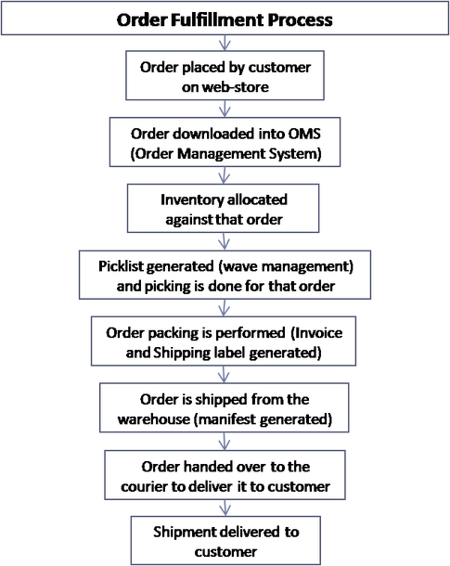

The scenario discussed above is an ideal scenario where the inventory is stocked in the Warehouse. There can be other 2-3 possibilities where the inventory is not stocked in the warehouse, such as:
1. Back to back order fulfillment: In this case the operations download the orders and ask its runner to go to the vendor immediately and pick up the required SKUs from the vendor and bring it back to the fulfillment center to fulfill the order.
2. Drop shipment: In this case the orders are downloaded and handed over to the vendor directly to fulfill the orders and ship it to the customers.
3. Made to order: In this case, the orders are first taken from the customer and then the purchase order is raised to procure the SKUs of that order from the vendor.
Flipkart usually does the stocking model or the back to back order fulfillment model.
PRACTICAL: 10
Aim: Software Demo-Total ERP.

Total ERP:

Total ERP Software is designed to be a complete solution for business today Total ERP comes complete with the full sets of software in every installation.

Total ERP software include the following areas –

Different Modules of Total ERP are as follows

Accounts

Appointments

Banking

Budget

CRM

Delivery

Employee

Fixed Assets

General

Hire

Hospitality

Inventory

Manufacturing

Payments

Payrolls

Purchases

Sales

Utilities

Work shops

Accounts:
- ERP Software gives you maximum flexibility from the creation of your Chart of Accounts and Cost Centres to Real Time Reporting and easy to use Graphical presentation of data.
- Transparency of data is crucial to understand your accounts. ERP Software provides drillable information throughout its extensive reports.
- Drill into your Balance Sheet or Profit & Loss down to individual transactions in real time. Full Audit Trail is provided to track all transactions ensuring data integrity.

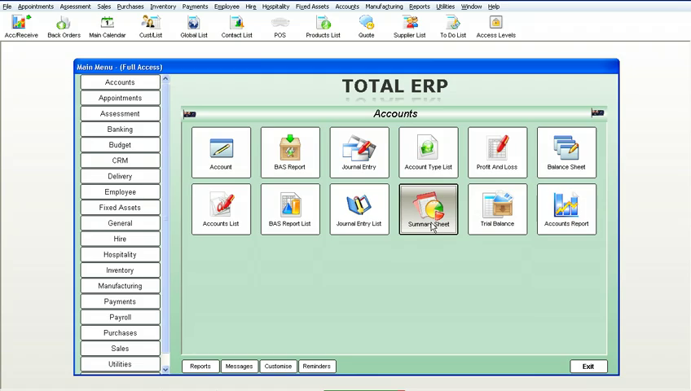

It includes
- Account
- BAS Report
- Journal Entry
- Account Type List
- Profit And Loss
- Balance Sheet
- Accounts List
- BAS Report List
- Journal Entry List
- Summary Sheet
- Trial Balance
- Accounts Report

Trial Balance:
- Run a trial balance or General Ledger at any time as required. As ERP Software is a true real time system, any transaction that has been created will appear on the report instantly.

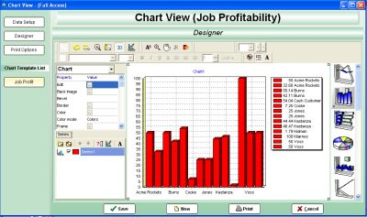

BAS Report:
- Instant BAS report printout. Preloaded with the correct codes, just requires date selection to load the numbers.
- If running multiple companies in the one file, you can create either a BAS or VAT report on the group of companies or an individual BAS/VAT report per company. BAS or VAT reports are also fully drillable allowing you to see the transactions that make up the field.

Summary Report:
- Look at a simple one page snapshot of your business, including cash in bank, accounts receivable, accounts payable, sales of different periods, cost of different periods and profit and loss over different periods.
- All figures again within this report are fully drillable to further investigate how these values are created.

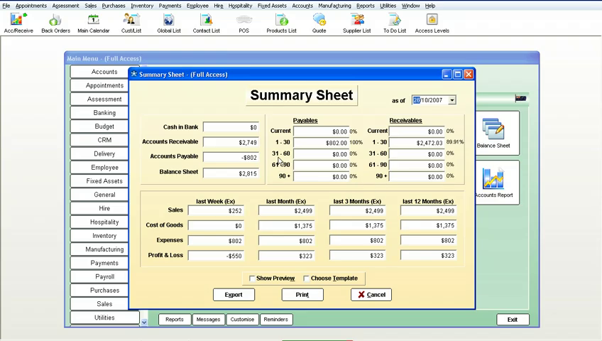

Customer Relationship Management (CRM):

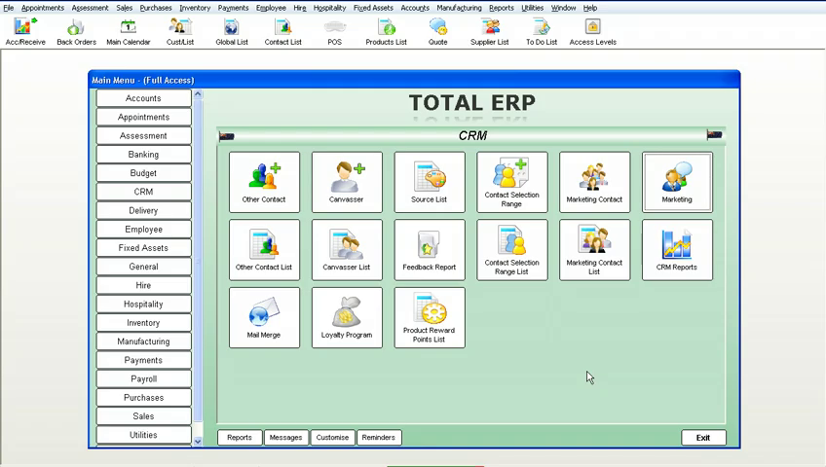

ERP Software provides CRM solutions for both Sales Force Automation and operational CRM.

Other Contact
- Canvasser
- Source List
- Contact Selection Range
- Marketing Contact
- Marketing
- Other Contact List
- Canvasser List
- Feedback List
- Contact Selection Range List
- Marketing Contact List
- CRM Reports
- Mail Merge
- Loyalty Program
- Product Reward Points List

Mail Merge:
- ERP Software has the facility to send mail merge documents to prospects, leads and customers based on nearly infinite selections.
- With our built in email and fax engines, the sending of documents takes seconds, not hours. An extremely powerful marketing tool!

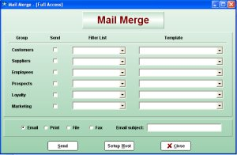

LoyalityProgrammes:
- ERP Software has the facility to send mail merge documents to prospects, leads and customers based on nearly infinite selections. With our built in email and fax engines, the sending of documents takes seconds, not hours. An extremely powerful marketing tool!

Contact:
- Complete details as required to keep an accurate customer database, which can be added to, or deleted from, depending on your requirements.
- The customer database is live to all areas of ERP Software which ensures that if any transaction involving a client is processed, the correct details including credit limits, pricing levels, past history, and contact and shipping details are automatically loaded and updated.
- No longer do you have to have multiple software packages to run your business.

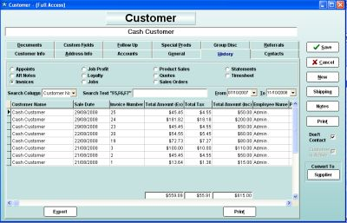

Contact List:
- Keeps a list of all contacts associated with the customer, which can be added to, or deleted from depending on your requirements.

Marketing Contact Listing

Employees:
- Complete details as required, to keep an accurate and extensive employee database or collection of information that is fully integrated with a complete business management and accounting system.
- This collection of information can be added to or deleted from depending on your requirements, even down to creating your own customisable fields and drop downs.

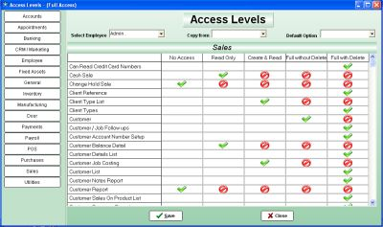

Rosters:
- ERP Software has a fully integrated roster module, not only is it attached to the Employee, but it can be directly loaded from the roster into Payroll.
- Assign all forms of leave on the roster, such as sick and annual leave, for any or all employees, which again will flow, directly into payroll.
- Great for tracking which store and what times staff need to be at work.

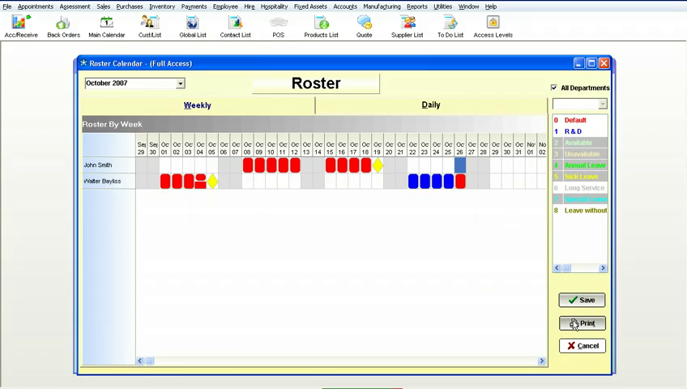

To Do List:
- Tasks can be assigned to different employees, who when logging on to their system, a screen will pop up to remind them to complete these tasks.
- These can be viewed and alter at any time and also reported on.

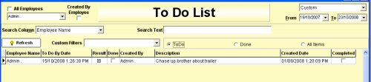

Customise Reports:

- Add your own specific fields to categorise your Employees. These fields can be text fields as well as 'Drop Down' fields.
- By making them drop downs you force a certain value to be selected, thus making your database consistent with what is displayed.
- There is even an option that you can turn on or off, with these fields that prevents the form from being closed if one of the values has not been entered.

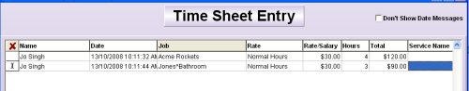

Personal Preferences:
- Allows each employee to set their own personal preferences, without accessing vital data, or areas of 'No Access'.
- They can completely customise the way ERP Software looks for them even down to which fields the cursor stops on, including colours displayed and columns on reports that are seen.

Representative Listing:
- Complete details as required, to keep an accurate Rep/Trainer database, a database or collection of information, that is fully integrated with a complete business management and accounting system, including a full calendar display screen, showing appointments and meetings for each and every Rep/Trainer
- This collection of information can be added to or deleted from depending on your requirements, even down to creating your own customisable fields and dropdowns.

Inventory:

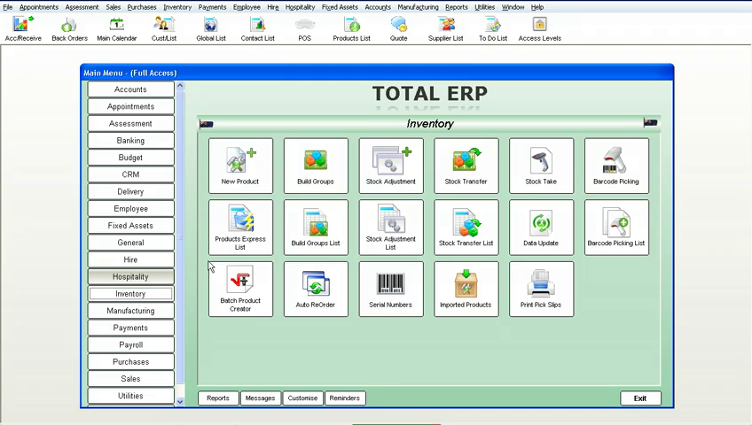

Features of ERP Software's Inventory Management include the following:
- New Product
- Build Groups
- Stock Adjustment
- Stock Transfer
- Stock Take
- Barcode Picking
- Product Express List
- Build Group List
- Stock Adjustment List
- Stock Transfer List
- Data Update
- Barcode Picking List
- Batch Product Creator
- Auto ReOrder
- Serial Numbers
- Imported Products
- Print Pick Slips

Barcode Picking:
- This module of ERP Software allows orders to be placed in the office, the warehouse then completes the order without touching the computer, by the use of a scanner.
- By scanning in their employee barcodes, the next prioritised picking slip will appear. ERP Software will then track how long it takes to pick the goods, and then how long it takes to pack the goods

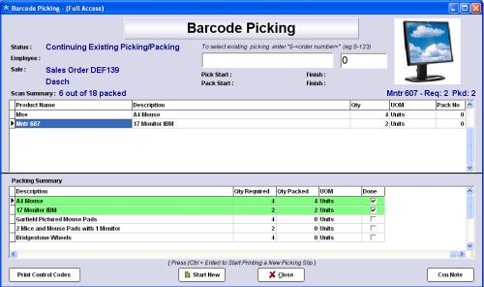

Build Groups:
- Also called a "Bill of Materials". This is where you can make a product from different, separate products. You can also have a group within a group or unlimited sub-products.
- No limits. Whenever one of these groups is sold, all the associated separate products are reduced by the number in the stock on hand list required to make the group.

Product Express List:
- Complete details as required, to keep an accurate and extensive stock management database, even down to creating your own customisable fields and drop downs.
- Fully drillable allowing you to retrieve any information on a product down to an amazing detail level.

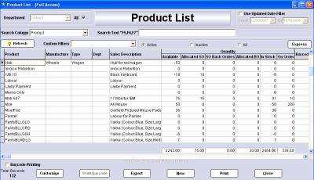

Stock Transfers:
- Keeps a complete record of any stock transfers between warehouses, stores etc. will even track who did what transfer, and at what time they did it.

Serial Number:
- Individual products can be tracked from purchasing to sales, with their own separate numbers.
- Keeps accurate records of exactly which customer has which product, when they brought it and who the supplier was that supplied it. Great for warranties etc.

Data Updates:
- Prices can be altered on mass with the push of one button, by Department, Code, Group, etc. You can set adjustments as a fixed value or as a percentage change, as a positive or a negative.
- If you turn on a preference in ERP Software, any product cost change will automatically adjust the sell price, keeping the same margin as before the cost change.

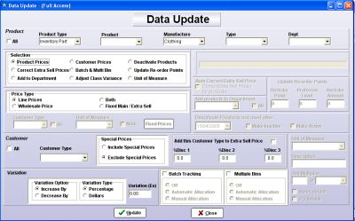

Stock Adjustments:
- Great for adjusting stock due to theft, lost stock or unknown.
- Simply assign it to an adjustment account and your stock balances and chart of account are kept accurate to the second.
Stock Take:
- These can be done by a number of methods. 1. Directly entering the count into the program. 2.
- By exporting out to Microsoft Excel and adjusting the spreadsheet in Microsoft Excel, then importing the spreadsheet back into ERP Software and assigning an adjustment value account. 3.
- By the use of a handheld unit, this will interface directly with ERP Software. With the addition of a scanner, stock takes become a breeze to do and what would normally take a team of people eight hours to complete, can be accomplished in less than two hours with the scanner unit.

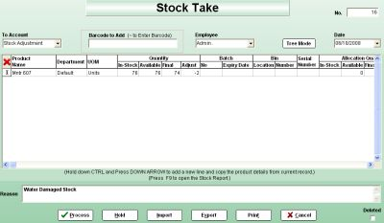

Employee:
- ERP Software helps you measure and increase employee productivity.
- Real Time integration of Jobs, Sales, Timesheets and Rosters within ERP Software means you can track, measure and respond immediately to fine tune employee activities .

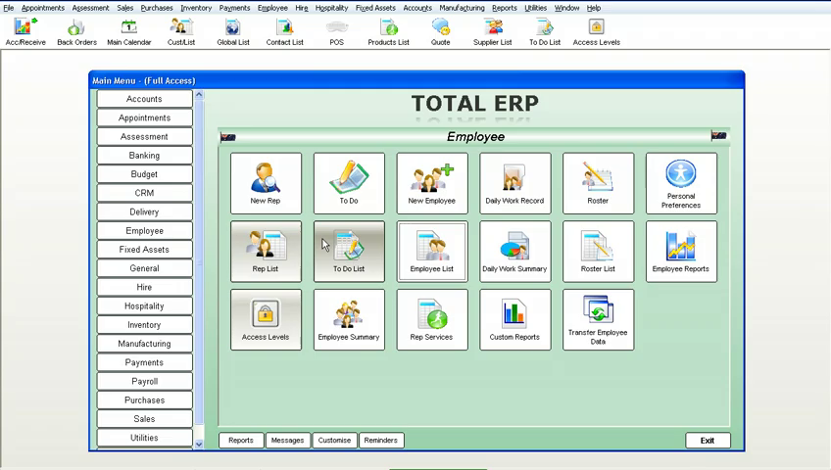

It includes:
- New Rep
- To Do
- New Employee
- Daily Work Report
- Roster
- Personal Preference
- Rep List
- To Do List
- Employee List
- Daily Work Summary
- Roster List
- Employee Reports
- Access Levels
- Employee Summary
- Rep Service
- Custom Reports
- Transfer Employee Data

New Employees:
- Complete details as required, to keep an accurate and extensive employee database or collection of information that is fully integrated with a complete business management and accounting system.
- This collection of information can be added to or deleted from depending on your requirements, even down to creating your own customisable fields and drop downs.

Rosters:
- ERP Software has a fully integrated roster module, not only is it attached to the Employee, but it can be directly loaded from the roster into Payroll.
- Assign all forms of leave on the roster, such as sick and annual leave, for any or all employees, which again will flow, directly into payroll. Great for tracking which store and what times staff need to be at work.

To Do List:
- Tasks can be assigned to different employees, who when logging on to their system, a screen will pop up to remind them to complete these tasks. These can be viewed and alter at any time and also reported on.

Customise Reports:
- Add your own specific fields to categorise your Employees. These fields can be text fields as well as 'Drop Down' fields.
- By making them drop downs you force a certain value to be selected, thus making your database consistent with what is displayed.
- There is even an option that you can turn on or off, with these fields that prevents the form from being closed if one of the values has not been entered.

Personal Preferences:
- Allows each employee to set their own personal preferences, without accessing vital data, or areas of 'No Access'.
- They can completely customise the way ERP Software looks for them even down to which fields the cursor stops on, including colours displayed and columns on reports that are seen.

Representative Listing:
- Complete details as required, to keep an accurate Rep/Trainer database, a database or collection of information, that is fully integrated with a complete business management and accounting system, including a full calendar display screen, showing appointments and meetings for each and every Rep/Trainer. This collection of information can be added to or deleted from depending on your requirements, even down to creating your own customisable fields and dropdowns.

Sales:
- ERP Software gives you maximum flexibility, combined with rock solid control over every aspect of your sales processes and cycles from the very first contact with a prospect, all the way through to them becoming a customer.

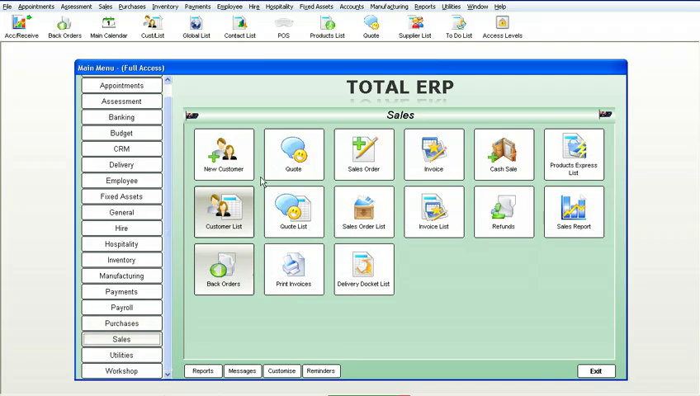

- New Customer
- Quote
- Sales Order
- Invoice
- Cash Sale
- Product Express List
- Customer List
- Quote List
- Sales Order List
- Invoice List
- Refunds
- Sales Reports
- Back Orders
- Print Invoice
- Delivery Docket List

Customers:
- Complete details as required to keep an accurate customer database, which can be added to, or deleted from, depending on your requirements.
- The customer database is live to all areas of ERP Software which ensures that if any transaction involving a client is processed, the correct details including credit limits, pricing levels, past history, and contact and shipping details are automatically loaded and updated.
- No longer do you have to have multiple software packages to run your business.

Customer List:
- An extensive and complete history of every quote, sales order, invoice, cash sale, statement, appointment etc that you have made with this customer.
- These can at any time be simply drilled into to open the original transaction that makes up the report.
- If you have the phone system connected to ERP Software this list will even include calls made to the customer.

Quotes:
- Unlimited number per individual customer or job, with one button conversion to invoice, sales order, repair, another quote, or smart order.
- Any special price quoted on for a customer can be automatically stored and always used as that customer's price for that product.
- Can be faxed, emailed, or printed in multiple formats, all from the quote screen, asERP Software has it's own built-in fax and email engine, so no external software is required to complete these operations.

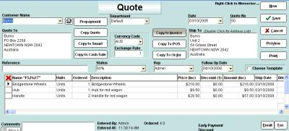

Quote List:
- Estimate sales by judging how likely obtaining the quote is, by using the status options to reflect the likelihood of making the sale.
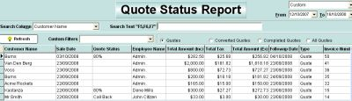

Sales Orders:
- Used as a confirmation of a sale prior to invoicing. ERP Software sales orders come with full picking slip and delivery docket capacity. These can also be easily converted to any number of options from invoices to smart orders etc.

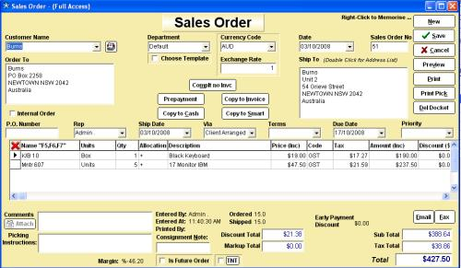

Cash Sales:
- Can be faxed, emailed or printed in multiple formats, all from the cash sale screen, as ERP Software has its own built-in fax and email engine, so no external software is required to complete these operations
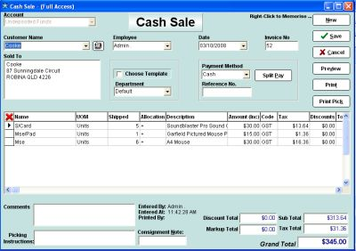

Invoicing:
- Can be faxed, emailed or printed in multiple formats, all from the invoice screen. As ERP Software has its own built-in fax and email engine, no external software is required to complete these operations.

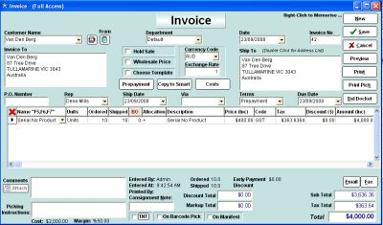

Refunds:
- Can be faxed, emailed or printed in multiple formats, all from the refunds screen, as ERP Software has its own built-in fax and email engine, so no external software is required to complete these operations.
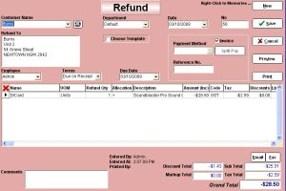

Delivery Dockets:
- Complete printout of all the information as required for the delivery of the customers goods.
Workshop:

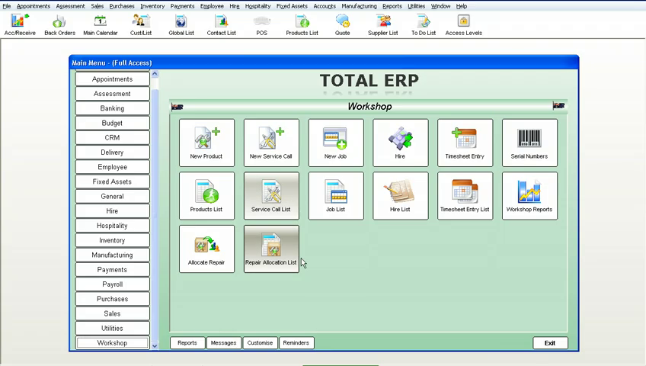

- ERP Software gives you enormous flexibility and maximum control in managing all aspects of your workshop, servicing and maintenance requirements, from tracking warranty costs, on-site calls to automated scheduled servicing. ERP is fully integrated to track all of your servicing inputs including parts, time and labour.

- New Product
- New Service Call
- New Job
- Hire
- Time sheet Entry
- Serial Numbers
- Product List
- Service Call List
- Job List
- Hire List
- Timesheet Entry List
- Workshop Reports
- Allocate Repairs
- Repairs Allocation List

Repair Allocation List:
- Book in repair work with a client, internally or externally, these can be warranty or service calls etc. Also track repair work for assets you own, rent or hire giving a complete breakdown of all costs involved with keeping that asset.

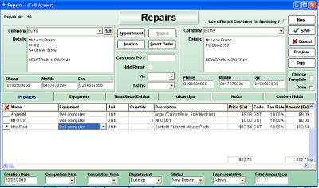

Workshop Report:
- Full workshop management with reports including work-in-progress, staff costing, job costing, job profitability and stock control with the ability to barcode-scan in stock used for the jobs in the workshop. Stock can be automatically ordered from the repair.

Serial Number:
- Serial number tracking is active on all repairs allowing you to track full history on repaired items and warranty periods on any item.

Time Sheets:
- Fully integrated with time sheet entries and payroll. Great for tracking hours spent on jobs within the system.

